Software Requirements Specification Template

Show Time Tickets

Software Requirements Specification

1.3

06/16/2020

Sai Naveen Bhargava Gajavalli
Chaitanya Popuri
Praneeth Reddy Kalluri
Pavan Sai Kumar Reddy Kamjula
SaiPrasad Bobbilla
Pranay Allikanti

Submitted in partial fulfillment
Of the requirements of
CSIS 44-691 Graduate Directed Project 1

Revision History

Date | Description | Author | Comments
<date> | <Version 1> | <Your Name> | <First Revision>

Document Approval

The following Software Requirements Specification has been accepted and approved by the following:
Signature | Printed Name | Title | Date

Table of Contents

Table of Contents Page Number

- Introduction
  - Purpose
  - Scope
  - Definitions, Acronyms, and Abbreviations
  - References
  - Overview
- General Description
  - Product Perspective
  - Product Functions
  - User Characteristics
  - General Constraints
  - Assumptions and Dependencies
- Specific Requirements
  - External Interface Requirements
    - User Interfaces
    - Hardware Interfaces
    - Software Interfaces
    - Communications Interface
  - Functional Requirements
  - Use Cases
  - Class/Objects
  - Non-Functional Requirements
3.5.1. Performance
3.5.2. Reliability
    - Availability
    - Security
    - Portability
  - Inverse Requirements
  - Design Constraints
  - Logical Database Requirements
  - Other Requirements
  - Prototypes (for complete project)
  - Use Case Diagrams
- Design
4.1. ER diagram
4.2. GUI
- Analysis Models
4.1. Data Flow Diagram
4.2. Sequence Diagram

1. Introduction

1.1. Purpose

The purpose of the Show Time Tickets application is to book the movie tickets online by selecting the location, movie, theatre preferences. The application lets the user select the seats according to their preference.

1.2. Scope

The application allows different users to register and log in with their respective credentials. The user can book movie tickets based on location, movie, and theatre preferences. After finalizing the preferences the user can select the seats from available seat layout. Once the seat selection is done the user is directed to the payment activity. Here the user can select one of the payment methods and can also add promotional codes if available. If the payment is successful the user will get an email attached with a ticket.

1.3. Definitions, Acronyms, and Abbreviations

XML (Extensible Markup Language): XML is a markup language much like HTML and was designed to display documents over the internet. In this project, XML is used to create the user interface of the application.

ER Diagram (Entity Relationship Diagram): An Entity-Relationship (ER) Diagram is a type of flowchart that illustrates how “entities” such as people, objects, or concepts relate to each other within a system.

API (Application Programming Interface):

The application programming interface is a computing interface that defines interactions between multiple software intermediaries.

AVD (Android Virtual Device): An Android Virtual Device is a device configuration that is run with the Android emulator.

IDE (Integrated Development Environment): The Integrated Development Environment is a software application that provides comprehensive software development facilities for computer programmers.

1.4. References

https://www.lucidchart.com/pages/ - To create ER diagrams.

1.5. Overview

The application helps the users to eliminate the efforts to go to the movie theatre for purchasing tickets. This application will book the movie ticket online based upon user preferences. In this, we have a Home screen where the latest movies will be displayed, Login screen which includes users to register and log in with their credentials, a facility to select the available seats in the theatre and a simple payment method screen which allows user to select from different types of payment methods.

2. General Description

2.1. Product Perspective

The Show Time Tickets application runs on the Android platform. Users can access the application by installing the .apk file in their android devices.

2.2. Product Functions

By using this application, the users will be able to book movie tickets online by choosing different theatres at different locations. Users have the facility to see the ratings and reviews of each theatre which will be very helpful while booking a ticket. Each user has a separate login credential which allows the user to use the available promotions and discounts on their accounts.

2.3. User Characteristics

According to this application, customers are the only users. The application will direct the users to perform the available operations.

2.4. General Constraints

As of now, this application scope is limited to only a few cities.

To make use of the application services the user must register with their Email.

The application is only available for android devices.

2.5. Assumptions and Dependencies
Android users can only access the application services. Different payment methods can be saved by the users in the application which will be easy while doing the ticket payment.

3. Specific Requirements
3.1 External Interface Requirements
    - User Interfaces
The user interface plays a major role in the success of the application. This application has the following GUI components:
- Images
- Card views, recycler views
- Buttons
- Navigation bar

    - Hardware Interfaces
The application runs on the Android platform. The application can be used on android devices like smartphones, tablets. Below are the hardware specifications:
- Desktops installed with the below mentioned operating system and software.
- Android device to run the application.
- The application will use cloud storage.

    - Software Interfaces
The system configuration helps to link the hardware and the application. The software tools that are used for developing the application are:
- Operating System: Windows 10
- IDE: Android Studio
- Emulator: Genymotion
- Database: Firebase

3.2 Functional Requirements
- Login activity: This activity helps the registered customers to log in with their respective credentials. If the users forget the password they can reset the password. This activity also helps the new users to register.
- Edit and view profile activity: This activity allows users to modify their profiles. The saved payment methods are listed here.
- View movie listing: This activity helps the customers to view the list of movies and select them according to their choice.

- Search/Filter: Search functionality helps the customers to search for movies according to their choice. The customers are provided with a search button where they can search for movies according to location, movie, and theatre preferences.

- View movie timing: This activity helps the customers to view show timings for movies so that they can select the movie according to their convenience.

- Seat activity: After selecting the movie the users are directed to this activity. Here the users can select the seat according to their preference.
- Checkout: This activity helps the customer to checkout for payment after they added items in the cart.

- Payment Activity: After selecting the seats the users are directed to the payment activity. In this activity, the users can select the saved payment methods or a new payment method to purchase the tickets.
- Ticket Activity: If the payment is successful the users are directed to this activity. Here the users can view the ticket. The ticket will also be mailed to the user's E-mail address.
- Cart management (add, delete): This activity helps customers to add movie tickets to the cart and can also delete the movie tickets.

- Notification: Customers will receive a notification to their mailing address once they finished purchasing the tickets.

- Check history: In this activity, Customers can view their previous ticket purchases.

- Order management (cancel tickets): In this activity, Customers are provided with the option to cancel their tickets if they wish to cancel.

- FAQ (email, textbox): Customers are provided with a section of frequently asked questions in the application. They can email or text for their queries.

- Live chat: Live chat is a bi-directional communication between customer and application backend team.

- Feedback: Customers can provide their feedback with ratings.

- Admin: Admin has all the access privileges such as edit movie listing, ticket modifications if necessary, etc.

- Login: This activity is used to login admins for the project. There are six admin accounts in the project.

- Movie management (add, delete): This activity is used to add, edit, or delete the movies as per requirements.

- Movie listing: This activity is used to display the movie on the list.

- Reminder: This activity is used to send notifications to the users. For instance, sending a notification to the user two hours before the movie time.

- Ticket notification: This activity is used to send confirmation to the users.

4. Design
4.1. ER diagram
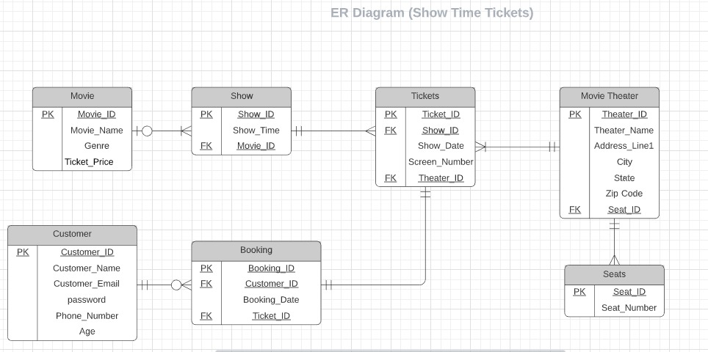
- There are 7 entities in the above Entity-Relationship diagram. They are as follows:
- Customer
- Booking
- Tickets
- Show
- Movie
- Movie Theatre
- Seats
- Customer_ID, Booking_ID, Ticket_ID, Show_ID, Movie_ID, Theatre_ID, and Seat_ID are the primary keys in their respective entities.
- Customer_ID and Ticket_ID are the foreign keys in the Booking entity.
- Show_ID and Theatre_ID are the foreign keys in the Tickets entity.
- Movie_ID is the foreign key in the Show entity.
- Seat_ID is the foreign key in the Movie Theatre entity.
Relationships between the above entity relationship diagram as follows:
- Customer – Booking - 1:M
- Booking – Tickets - 1:1
- Movie – Show - 1:M
Show – Tickets - 1:M
- Movie Theater – Seats - 1:M
- Movie Theater – Tickets - 1:M

4.2. GUI
- Login Activity: This activity is used to sign up or log in to the user. Users can also reset his password with the help of the “Forgot Password?” functionality.
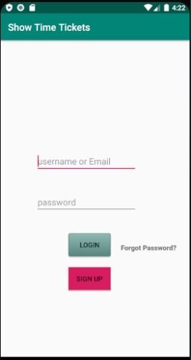

- Registration Activity: This activity is used to register the user details.
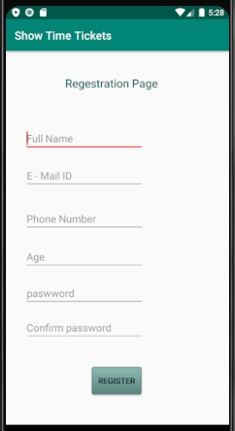

- Forgot Password: This activity is used to reset the password when the user forgot it.
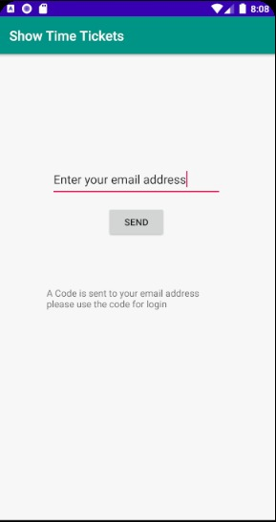

- Home Activity: This activity is used to search for a movie based upon a movie name, theatre name, or city. And also, it displays the recent or trending movies that are added in the application.
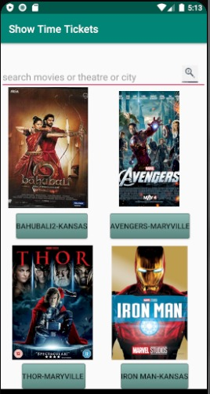

- Movie Show Selection Activity: This activity is used to select the movie shows based upon availability.
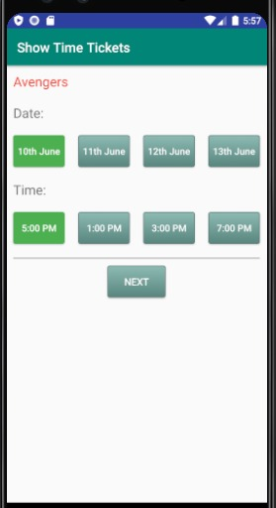

- Seat selection Activity: This activity is used to select the seats for a particular movie based upon seat availability.
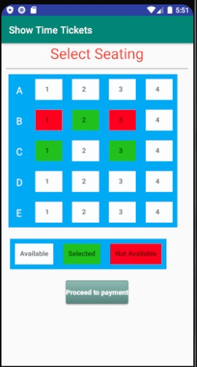

- Payment Activity: This activity is used to complete the ticket payment by entering the user card details.
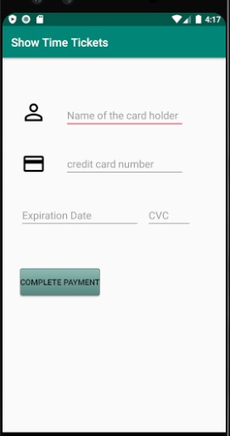

- Ticket Confirmation Activity: This activity is used to display the ticket confirmation details to the user.
